Indoor Position System

Abstract:

Indoor Positioning System is same as Global Positioning System (GPS), But the main difference is GPS is widely used for providing outdoor navigations and global locations, it does not provide indoor navigations. So, to overcome this issue we have proposed to develop an Indoor Positioning System for organization which provides indoor navigation services and it is operating with user’s mobile terminal. This system may developed by using either Bluetooth or WI-FI technology. In both technologies external hardware is needed that is for Bluetooth technology beacons and for WI-FI technology WI-FI routers as well as WI-FI modules. While beacon has low power consumption and medium cost than WI-FI routers plus WI-FI modules, we suppose to use Bluetooth technology. By using smart phones and beacons this system provides the path from source to destination which displays on the inside map of institute. It also gives navigation and notification to user when user reaches to the destination. IPS system uses internet connection, GPS and Bluetooth devices for navigation.

Screen Shots of Application:

- Splash Screen

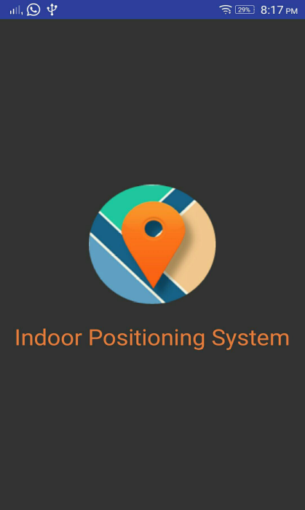

- Registration Page
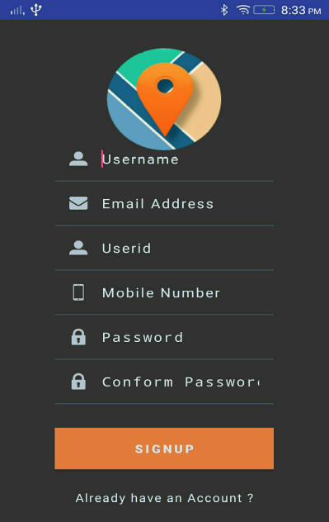
- Login page
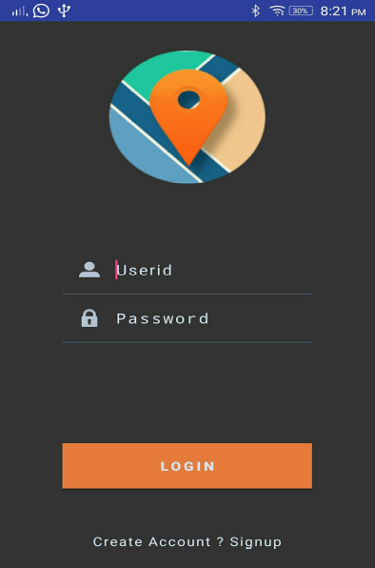
- Scanning page


- MAP Activity
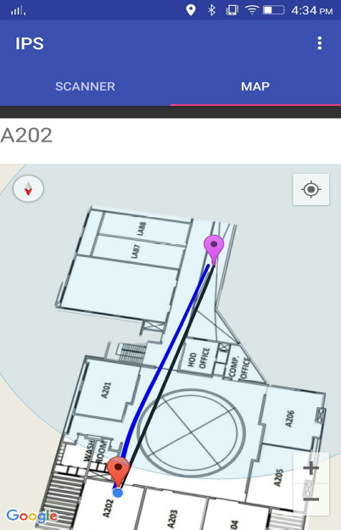
- FAQ Page
